| **Software Development task sheet** | **03** |
| --- | --- |
| **SQL mini project** |  |

You have been asked to develop a database for a small company that provides web design services.

**Dragon Web Services** offer simple or more complex web sites for customers. Customers request a number of pages, if they prefer custom CSS or not and if they need a shopping cart.

They are assigned a developer based on the customer requirements.

Here is the current simple spreadsheet data they are using to track jobs with some sample data.

**Part 1 – creating the database**

1. Write a short explanation of the key features of a database.

* Records (rows)
* Columns (attributes / fields)
* Primary Key (unique identifier)
* Data Types
* Adding, editing, deleting, and searching for records

1. Explain the concept of normalisation.
   1. Why is this a useful tool?

Normalisation helps **avoid data inconsistency and redundancy** by creating relational databases that have atomicity, primary keys, no duplication and attributes with no transitive functional dependency.

It’s also useful for **saving storage space**, making the database **more flexible (**easier to search, update and delete data), and **more secure** (you can make some entities read only, or limited access).

* 1. What does it help prevent?
* Data inconsistency and redundancy
* Multiple values in a column for any one record
* Duplication
* Transitive functional dependency
* Difficulty to use

1. Using the case study information, normalise the data to Third Normal Form.
   1. Show your steps clearly and explain what you have done and why. 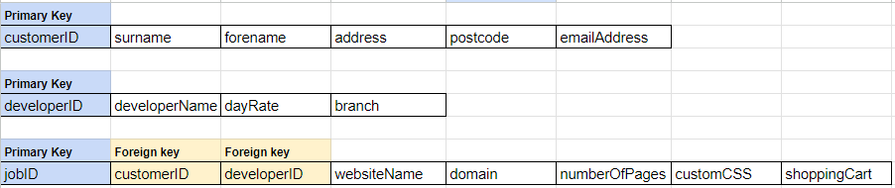

* **Customers** - I first created a **primary key** for customers so that each person is uniquely identified in the case of matching names or addresses or multiple jobs for the same person.
* **Developers** - I created a new table with a new primary key for the developers since they were not dependent on the ‘CustomerID’ primary key. This table also **removes duplication** of developers in the initial table
* **Jobs** - I created a new table for jobs with a new primary key. This is because the websiteName and domain etc had transitive functional dependency when in the customers table. (multiple jobs could depend on the same customerID)
* **3NF** - the attributes I assigned to each of the three tables all have no transitive functional dependency so nothing more needs to be done for 3NF

1. Illustrate the table structure with an Entity Relationship Diagram that shows the relationships between tables. 
2. Create SQL statements that will create and populate these database tables.

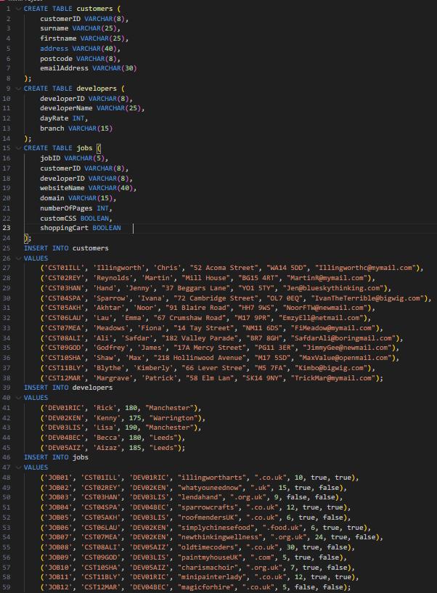

1. Show the results of setting up this schema in a suitable tool:

JDoodle:

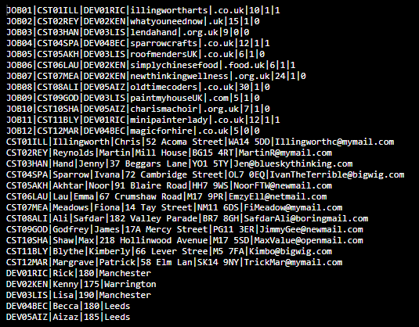

**Part 2 – CRUD operations (Create, Read, Update, Delete)**

***For each of these operations, show before and after states of the table(s)***

1. Show all records in each table you have made.



1. Amend the record for Ivana Sparrow. Her required domain should be .com, not .co.uk



Before:



After:

1. Amend the record for Max Shaw, his email address is wrong and should say: max.value@openmail.co.uk



Before:



After:

1. Add a new record as follows:

Johnson, Winston. 123 Collier Walk, Hattersley, SK14 9ZZ, WinstonTheGreat@bobmail.co.uk. Website: marleyfansuk.org.uk comprising 10 pages with custom css but no shopping cart. Kenny will be developing this site.



Before: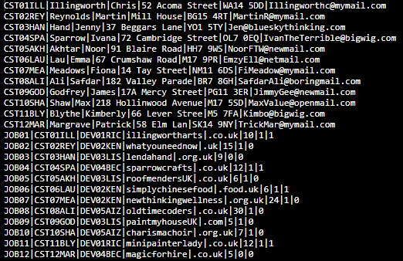

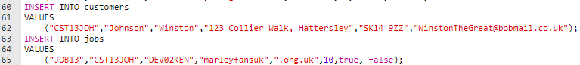

After: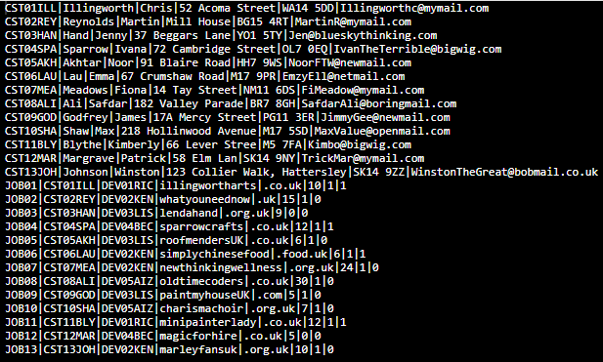

1. Delete the records for Chris Illingworth



Before: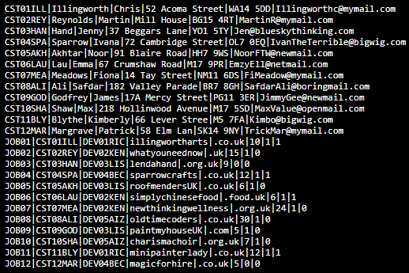

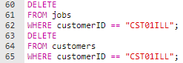

After: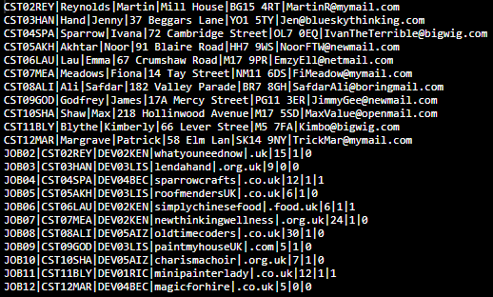

**Part 3 – Querying the database**

1. Create and show the query and output data for the following queries.   
   1. Show all data for clients whose surname begins with ‘A’



* 1. Show all data for clients wanting custom CSS



* 1. Show all data for clients who want shopping carts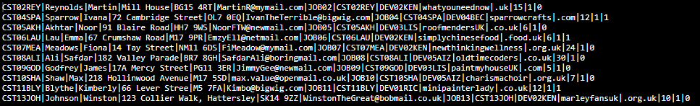





* 1. Show the surname, forename, website name and domain for every website that will have a .co.uk domain.  
     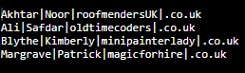
  2. Show all website details that are being developed by Lisa or Rick  
     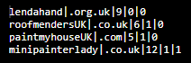
  3. Show client surname, website name and domain, for every website being worked on in the Leeds office  
     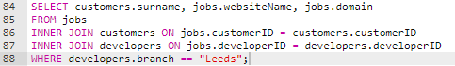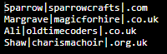
  4. Produce a client list with all details of work being done by the Manchester branch.   
     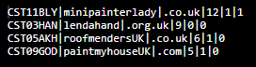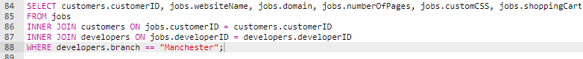
  5. Produce a client list with all details of work being done by the Warrington branch.  
     

